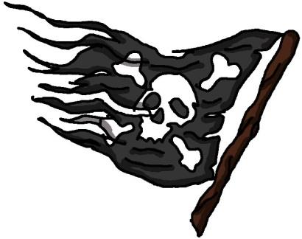Pirates Plunder at Port Madison!
Ahoy Matey!
Greenbox will provide Grog, a wee bit of Rum, and soft drinks. (Pirate translation: 1/6 bbl Sierra Nevada Summer Ale and Mt Gay Rum)
Dinner will provide Bones, Vino and the rest of the Grog, and Greens. (Pirate translation: Baby Back Ribs, finish the keg, salad, red & white wine)
Breakfast on Sunday will be catered by the Famous Pirates Bruce & Bobbi Campbell
Pirates Boats A - L: please bring a side dish to share for Dinner
Pirates Boats M - Z: please bring a desert to share for Dinner
Saturday, June 22
10:00-11:00 Meet at Shilshole
11:00 Race over to Pt Madison
5:00 Greenbox
7:00 Dinner
Sunday, June 23
8:30-9:45 Breakfast
11:00-12:00 Meet at Pt Monroe
12:00 Race back to Shilshole

Race Instructions
Committee Boats: M/V Christopher C (Chris Cowman) & S/V Anneke (Fred Pot)
VHF Channel Channel 72
Time Limit 1600 hours Saturday (Please call R/C on 72 if you retire)
1600 hours Sunday (Please call R/C on 72 if you retire)
Race Course A chart is attached with short, medium, and long course. Check with committee boat prior to race. R/C will display S, M, L for which course. Sunday is a reverse of the “S”, “M”, or “L” course.
Special Rules This is a fun race, no flying sails.
Safety Equipment PIYA category III required
Pirates Plunder at Port Madison 2013
Competitor List and Start Times
Reverse start using modified PHRF/Open Class Handicaps. Starting times will be assigned so that the higher handicap boats start earlier than the faster boats with the goal being each class finishes at about the same time.
C |  | Hofbrau | Catalina 25 | Steve Hoffman | 237 | 11.00 | 11.00 | 11.00
CR | 61 | Sunshine | Santana 27 | Mike Milburn | 229 | 11.01 | 11.01 | 11.02
C | 4383 | Anneke | Catalina 30 | Fred Pot | 210 | 11.03 | 11.04 | 11.05
C | 27696 | Moonshine | Yankee 30 | Kirk Fraser | 210 | 11.03 | 11.04 | 11.05
C |  | Skimmer | Catalina 30 | Ian Campbell | 210 | 11.03 | 11.04 | 11.05
C |  | Reverie | Dufour 31 | Jeff Snell | 195 | 11.04 | 11.06 | 11.09
CR | 19902 | Strider | Ranger 33 | Keith Johnson | 188 | 11.05 | 11.07 | 11.10
C | 150 | Velella | Wylie 31 | Ryan Helling | 186 | 11.05 | 11.07 | 11.10
CR | 39010 | Runaway | Norlin 34 | Phil Calvert | 166 | 11.07 | 11.10 | 11.14
C |  | Flying Eagle | Oyster 46 ketch | Jack Sullivan | 166 | 11.07 | 11.10 | 11.14
C |  | Summer Salt | Hunter 35 | Lori Petersen | 162 | 11.08 | 11.11 | 11.15
CR | 79150 | Evolo | Pearson 36 | Brian Ferris | 156 | 11.08 | 11.12 | 11.16
CR |  | Roxie | Jean 35 | Michael Massa | 138 | 11.10 | 11.14 | 11.20
R | 59847 | Izakaya | Dash 34 | Ian Christiansen | 138 | 11.10 | 11.14 | 11.20
CR | 79139 | Blue Heaven | C&C 34+ (36) | Ken Wickman | 126 | 11.11 | 11.16 | 11.23
C |  | Tinuviel | Hunter 41 | Michael Hendrick | 123 | 11.11 | 11.16 | 11.23
CR |  | Forget Me Knot | Bene 47 | Don Glockner | 102 | 11.14 | 11.19 | 11.27
CR | 11220 | Panther | Swan 48 | Chris Warner | 90 | 11.15 | 11.21 | 11.30
CR | 48603 | Plein Air | Morris 48 | Randy Holbrook | 87 | 11.15 | 11.22 | 11.30
R | 79048 | Black Knight | Bene 36.7 | Suzanne Lusnia | 81 | 11.16 | 11.22 | 11.32
R | 39122 | Katzzengammer | Dehler 39 | Gordon Stoll | 81 | 11.16 | 11.22 | 11.32
R | 18927 | Anomaly | SC 50 | Bill Elmer | 36 | 11.20 | 11.29 | 11.41
R | 56203 | Double Take | J145 | Brad Baker | -3 | 11.24 | 11.35 | 11.49

Starting Sequence: We will try to start on the hour at 11:00 GPS time, but be prepared after 11:00 if no wind and start with your minute offset. We will try to communicate over VHF 72 also.
05 minutes before start sequence Blue Flag & Sound
01 minute before start sequence Blue Flag comes down
00 minute starting sequence starts Red Flag & Sound
Other signals:
Course: “S” Short Course, “M” Medium Course, “L” Long Course will be displayed
Postponement: AP pennant (red & white vertical stripes) & 2 sounds
Pirates Plunder at Port Madison 2013
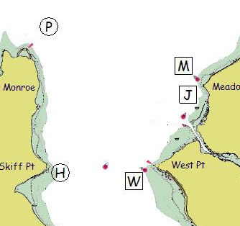

J – Shilshole Bay N Mooring Bouy (LL #16785)
H – Temporary mark at Skiff Pt – 47 39.660”N 122 29.572”W
M – Meadow Pt Bouy (LL #16765
P – Temporary mark 0.75 NM NNE of Pt Monroe
W – West Pt Buoy (LL #16805)

Pirates Plunder at Port Madison 2013
Start R/C boat: M/V Christopher C –42’ Power- Chris Cowman, skipper
Finish R/C boat: S/V Anneke – 30’ Catalina Sail-Fred Pot, skipper

Short Course (6.01 NM) R/C displays “S”
Start near Shilshole Bay N Mooring buoy “J”
Round West Point Buoy “W” to starboard
Finish at Pt Monroe temporary mark “P”

Medium Course (8.63 NM) R/C displays “M”
Start near Shilshole Bay N Mooring bouy “J”
Round West Point Buoy “W” to starboard
Round meadow Pt Bouy “M” to port
Finish at Pt Monroe temporary mark “P”

Long Course (12.19NM) R/C displays “L”
Start near Shilshole Bay N Mooring buoy “J”
Round West Point Buoy “W” to starboard
Round Skiff Pt temporary mark “H” to starboard
Round meadow Pt Bouy “M” to port
Finish at Pt Monroe temporary mark “P”

