Mark Mayer Opening Day Race
May 8, 2016

Classes and Class Flags

Class | Class Type | Class Flag | Class Flag Illustration | Course Readerboard Row
1 | J-22 | Numeral Pennant 1 | 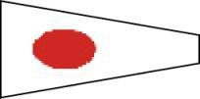 | Top
2 | PHRF | Numeral Pennant 2 | 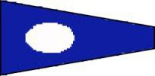 | Middle
3 | PHRF | Numeral Pennant 3 | 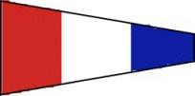 | Middle
4 | Cruiser - Racer | Numeral Pennant 4 | 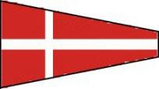 | Bottom

