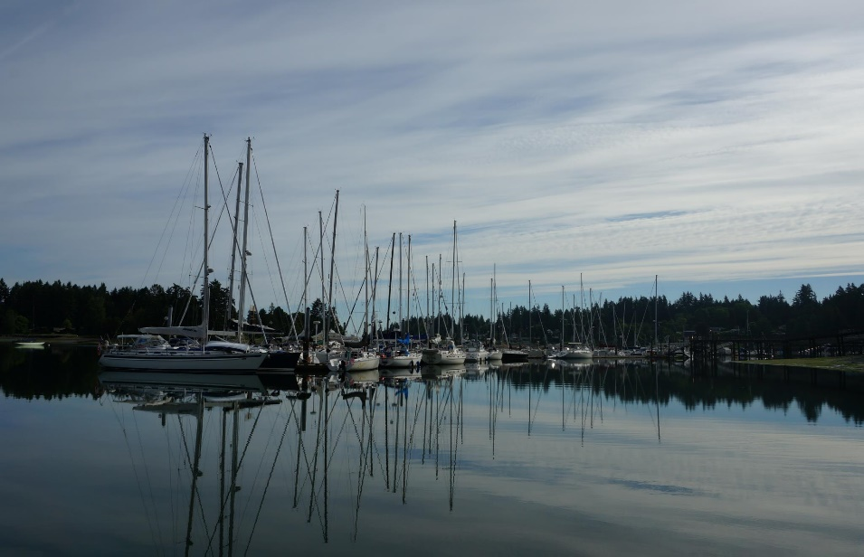  
 **Cruise & Snooze & Sailboat Rendezvous**

**June 25-26, 2016**

Thank you so much for registering for Sailboat Rendezvous and Cruise & Snooze.  Here is the schedule for the weekend.

**11:00 Sat. Morning, Cruise and Snooze Racers.**  See **Sailing Instructions** below.

**SYC Boat Show, 2:00 - 5:00 .** Saturday afternoon will include a SYC Boat Show.  All participating boats will have a “Welcome Aboard” sign to let folks know they are welcome to come aboard and check out the interior and chat with the skipper and first mate.

**Greenbox. 5:30 - 6:30.**  Bring your appetizer to share.  Wine, beer and soft drinks provided.

**Dinner 7:00 - 10:00 and Awards Ceremony.**

Please bring your own table setting for dinner.  Bring a salad, side dish or dessert according to your last name.

A - G   Dessert

              H - P   Salad

              Q - Z   Side Dish

**Movie on the dock. 10:30 - 12:00 (or dusk)**

**Sunday 8:30 - 10:00 Breakfast** Sunday closes the event with the customary Cruise & Snooze Bruce & Bobbi Campbell 's Famous Big Breakfast; eggs, bacon, pancakes, pastries, fruit, juice, coffee.

**Cruise & Snooze Return Race.   Start time 1200 hour**

**Sailing and Race Instructions**

**Committee Boats:** ***M/V Portage Bay***(Denny Johnson)

**VHF Channel**  Channel 72

**Time Limit** 1600 hours Saturday (Please call R/C on 72 if you retire)  
 1600 hours Sunday (Please call R/C on 72 if you retire)

**Race Course** A chart is attached with short, medium, and long course. Check with committee boat prior to race. R/C will display “S”, “M”, or “L” for which course according to a South wind or a North Wind. Sunday is a reverse of the “S”, “M”, or “L” course.

**Special Rules** This is a fun race, no flying sails. Race Committee can change Sailing Instructions over channel 72 prior to the start sequence.

**Safety Equipment** PIYA category III required

Reverse start using modified PHRF/Open Class Handicaps. Starting times will be assigned so that the higher handicap boats start earlier than the faster boats with the goal being each class finishes at about the same time.

**Starting Sequence:** We will try to start on the hour at 11:00 GPS time, but be prepared after 11:00 if no wind and start with your minute offset. We will try to communicate over VHF 72 also. You are responsible for your start time and start.  
Saturday Start time: 1100 hours  
Sunday Start time: 1200 hours

05 minutes before start sequence Blue Flag & Sound  
01 minute before start sequence Blue Flag comes down  
00 minute starting sequence starts Blue Flag & Sound

**Other signals:**Course: “S” Short Course, “M” Medium Course or “L” Long Course will be displayed  
Postponement: AP pennant (red & white vertical stripes) & 2 sounds

**Start R/C boat: *M/V Portage Bay***(Denny Johnson)

Start is between Committee Boat (*S/V Portage Bay)* and green start mark

**Finish R/C boat: *M/V Portage Bay***(Denny Johnson)

Finish is between Committee Boat (*M/V Portage Bay)* and temporary green finish mark.

**Competitor List and Start Times**

(as of 1300h June 24)



**If a NORTH wind direction WIND DIRECTION**

**Short Course (5.294 NM) R/C displays “S”**

Start near Shilshole Bay N Mooring buoy “J”  
Round Meadow Point Buoy “M” to port  
Finish at Pt Monroe temporary mark “P”

**Medium Course (8.332 NM) R/C displays “M”**

Start near Shilshole Bay N Mooring buoy “J”  
Round Meadow Point Buoy “M” to port  
Round West Point Buoy “W” to starboard  
Finish at Pt Monroe temporary mark “P”

**Long Course (10.68 NM) R/C displays “L”**

Start near Shilshole Bay N Mooring buoy “J”  
Round Meadow Pt Buoy “M” to port  
Round West Point Buoy “W” to port  
Round Meadow Pt Buoy “M” to port  
Finish at Pt Monroe temporary mark “P”

**If a SOUTH wind direction WIND DIRECTION**

**Short Course (6.319NM) R/C displays “S”**

Start near Shilshole Bay N Mooring buoy “J”  
Round West Point Buoy “W” to starboard  
Finish at Pt Monroe temporary mark “P”

**Medium Course (8.867 NM) R/C displays “M”**

Start near Shilshole Bay N Mooring buoy “J”  
Round West Point Buoy “W” to port  
Round Meadow Point Buoy “M” to port  
Finish at Pt Monroe temporary mark “P”

**Long Course (11.42 NM) R/C displays “L”**

Start near Shilshole Bay N Mooring buoy “J”  
Round West Point Buoy “W” to starboard  
Round Meadow Pt Buoy “M” to starboard  
Round West Point Buoy “W” to starboard  
Finish at Pt Monroe temporary mark “P”

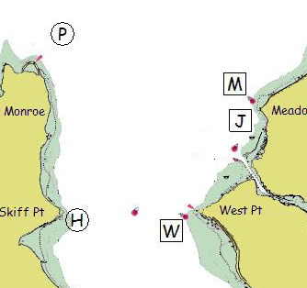

J – Shilshole Bay N Mooring Bouy (LL #16785)  
H – Temporary mark at Skiff Pt – 47 39.660”N 122 29.572”W  
M – Meadow Pt Bouy (LL #16765  
P – Temporary mark 0.75 NM NNE of Pt Monroe  
W – West Pt Buoy (LL #16805)