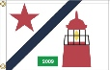
2017 Commodore’s Cruise
July 16th through July 21st
Henry Island to Ovens Island

Cruise Captains
Phil & Deanne Calvert 206-910-7977 Fred & Ann Pot 206-850-7664
Race Committee: Chris Warner & John Chuta

Sunday, July 16 5:00pm Henry Island Commodore’s Cruise Green Box Party
Get Cruise bags, flags, and cruise/race instructions!
7:00pm BBQ by Chef PC (Please bring (A-K) side or salad
(L-Z) dessert) *note:( please bring your own table settings for this cruise)
8:30pm Bonfire and S’mores

Monday, July 17 11:00am Start of Race from Henry Island to Sidney, B.C.
Powerboat Crab Catching Contest
Stay at Port Sidney Marina
Customs Check-in and check in at Sydney Marina
5:00pm Greenbox on covered dock near the ramp
Wine and Gingerbeer Tasting for best Chardonnay and Gingerbeer-prize given to boat for best in class Kids or Adults – best prize given! (Please bring a Ginger Beer and Chardonnay to sample…and maybe rum!)
Prize for the most crab, *must bring to greenbox, yum!
Sailboat/Powerboat Awards and Rubber Chicken Award*
Dinner on your own! Great choices in Sydney!

Tuesday, July 18 11:00am Start of Race from Sidney to Ganges

Check in at Saltspring Marina-call Dockmaster John Chuta on Ch 68 for

assignments.
5:00pm Greenbox on outer dock-Best Hat contest-prizes given! Kids and
adults!
Sailboat/Powerboat Awards and Rubber Chicken Award*
Dinner on your own or we are making arrangements to eat at Moby’s* at the top of the Ganges docks, if you desire around 7:00ish. Let Fred Pot know if you want to be included.

Wednesday, July 19 Lay Day in Ganges
3:00pm Rendezvous in Montague Harbor (everyone leaves around noon)
Perform Star Raft-Chris Warner in charge, Ch 68 when you arrive.
5:00pm Greenbox-boat to boat.
6:00ish Drone fly over picture of Star Raft, please smile!

Thursday, July 20 11:00am Start of Race from Trincomali Channel to Ovens Island
4:00pm Pirate theme “Treasure Hunt” maps available for kids to find gold coins and maps available for adults to find the bottle of grog (rum)
5:00pm Pirate theme Green Box Party
7:00pm BBQ Burgers and Chips and awards at Ovens for overall race
results! Sailboat/Power Awards and Rubber Chicken Award*
9:30pm Movie Night “Pirates of the Caribbean” on docks projected on a mainsail (technology allowing)

Friday, July 21 9:00am Final breakfast at dock on Ovens Island
10:00am Commodore’s Cruise ends, Sunshine Coast Cruise starts!
Boat Name | Attendee Name | children age?
Amihan | Brown, Robert
Amihan | Brown, Tess
Anomaly | Elmer, Kathleen
Anomaly | Elmer, William
Coho | Mundell, Catherine
Coho | Mundell, George
Flamingo Express | Chuta, Cynthia
Flamingo Express | Chuta, John
Forget Me Knot | Glockner, Carol
Forget Me Knot | Glockner, Donald
Izarra | Harvilla, Andrew
Izarra | Harvilla, Andrew - TBD
Jekamanzi | Hitchens, Brian
Kama Aina III | Ellison, Gwen
Kama Aina III | Ellison, Tyler
Lady Laura | Hitchens, Garth
Lady Laura | Hitchens, Laura
Lady Laura | Hitchens, Garth - TBD
Lightfoot | Leonard, Tom
Lightfoot | Leonard, Tom - TBD
Nooka | Bourlier, Doug
Nooka | Bourlier, Peggy
Nooka | Bourlier, John | John age 12
Nooka | Bourlier, Olivia | Olivia age 9
Panther | Murray, Pam
Panther | Warner, Chris
Puffin | Medley, Cici
Puffin | Medley, James
Puffin | Medley, James - TBD
Reliance | Koch, Andrew
Reliance | Koch, Mahalynn
Reliance | Koch, Baby | 3 years old
Runaway | Calvert, Phil
Runaway | Calvert, Deanne
Runaway | Calvert, John | 12 years old
Seattle Girl | Cay, Bruce
Seattle Girl | Cay, Kathryn
Seoladh | Ferguson, Ann
Seoladh | Ferguson, David
Seloadh | Ferguson, Cameron | age 17
Seloadh | Ferguson, Sheridan | age 18
Shenandoah | Wilder, Elizabeth
Shenandoah | Wilder, Elizabeth - TBD
Shenandoah | Wilder, Warren
Simplicity | Ehrenreich, Stuart
Simplicity | Ehrenreich, Stuart - TBD
Sound Dreams | Flock, Bonnie
Sound Dreams | Flock, Tony
Sound Dreams | Flock, Tony - Child | 15yrs old
Southern Star | Crossland, Kathryn
Southern Star | Crossland, Kathryn - TBD
Syrenka | Gove, Erin
Syrenka | Gove, Robert
Syrenka | Adamiak, Jan
Syrenka | Adamiak, Patrick
Tatoosh | Penny, Doug
Tatoosh | Penny, Doug - TBD
VREDEBEST | Pot, Fred
VREDEBEST | Pot-Staton, Ann
YES | Daviduk, Mick

Port Sydney Marina Map

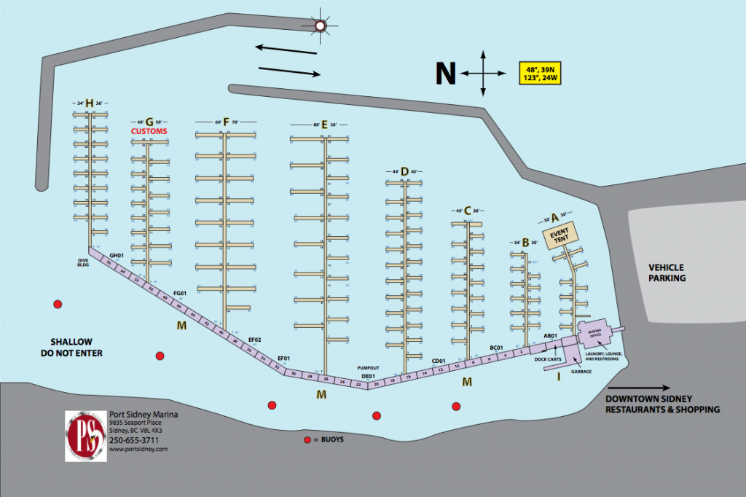
Mooring in Ganges
Please note the following preliminary docking plan:
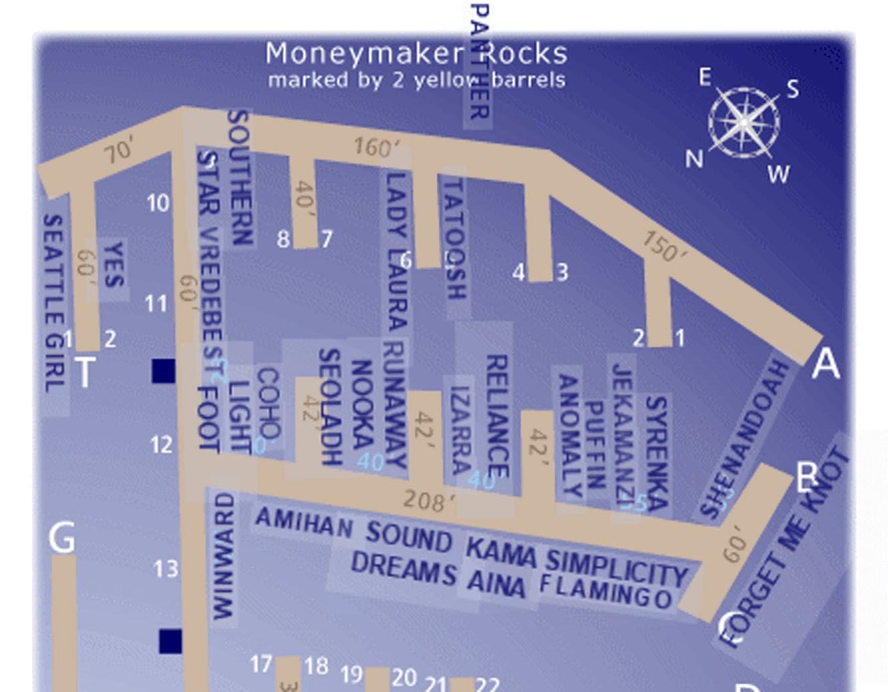
Dinner in Ganges
In the past Commodore’s Cruises we have been on our own for dinner in Ganges on Tuesday night. This year we arranged to have dinner together at Moby’s. Moby’s is located at the head of the marina. Let us know if you can’t make it to this dinner.

Sailing Instructions

No Flying Sails (spinnakers, A-sails, Code 0) this is a fun race; SYC handicapper will assign temporary ratings for the Commodores Cruise.
M/V TBD will be the Committee Boat with the official race committee. Every yacht receives a participation bag and burgee. Trophies for first three places in each class will be awarded each evening and overall on final night. Dockage at Port Sidney Marina is paid directly to the marina.
*Rubber Chicken Award: is given to the best boating maneuver, power or sail! An Honor to fly
on your spreader. Proper flag etiquette is also a major part of the Rubber Chicken. Beware!

Race Courses

Each of these races is point-to-point, and there are no marks of the course, except the start and finish lines. You may choose any route.

Monday
Start will be outside the North entrance to Roche Harbor. Look for “Portage Bay.” Course will be to Sidney Harbor, with finish to be in vicinity of harbor markers in Sidney Harbor. Distance will be approximately 10 miles.

Tuesday
Start will be outside the Sidney Harbor breakwater toward Ker Island to the North. Finish will be near entrance to Ganges Harbor, near Second Sister Island. Distance will be approximately 12 miles.

Thursday
Start will either be near Victoria Shoal in Trincomali Passage, or will be off Jackscrew Island in Houston passage, depending on the winds. Finish will be near Sharpe Point close to Ovens. Distance will be approximately 10 or 13 miles, depending on the course.

Race Instructions

Committee Boat: TBD

VHF Channel: Channel 72

Race Administrators: Phil Calvert & Fred Pot

Time Limit: 16:30 hours each day

Courses: As described above

Protests: Exonerate your protests with 720’s. If necessary, a Protest Committee will be convened. Protests to be filed within two hours of your finish. You can bribe the Race Administrators and Protest Committee.
(Note: Protest Committee are members of our Powerboat Attendees!).

Throw Outs: None

Start Times and Sequence

The schedule for races is the same for each race day:

10:55 a.m. Warning for Cruiser Class (Blue Flag up + Sound)
10:59 a.m. Blue flag comes down
11:00 a.m. Start for Cruiser Class (Blue Flag up + Sound)
11:04 a.m. Blue flag comes down
11:05 a.m. Start for Racer Class (Blue Flag up + Sound)

Code Flag “AP” Answering Pennant, with two signals means race is postponed.
The races will be Time on Time, meaning your finish times will be calculated based on course length and your rating.

Listen (Ch 72) and watch for sudden shortened courses!

Retiring yachts shall notify the Race Committee Boat on VHF 72. Race scoring will be the low point scoring system.

Trophies will be awarded for First, Second and Third place, and the week’s best performance in both classes.

Class | Boat Name | Attendee Name | Make/Model | Sail # | Temp NFS PHRF
Cruiser | Nooka | Bourlier, Douglas | Ranger 33 |  | 188
Cruiser | Jekimanzi | Hitchens, Brian | Pratique 35 |  | 180
Cruiser | Syrenka | Gove, Robert | Catalina 350 |  | 170
Cruiser | Shenandoah | Wilder, Elizabeth | Hunter 35.5 |  | 154
Cruiser | COHO | Mundell, George | Jeanneau 43 DS |  | 148
Cruiser | Tatoosh | Penny, Doug | Islander 40 |  | 123
Cruiser | Forget Me Knot | Glockner, Donald | Beneteau 473 |  | 102
Cruiser | Southern Star | Crossland, Kathryn | Hylas 54 |  | 84
Racer | Seoladh | Ferguson, David | Ranger 33 |  | 188
Racer | VREDEBEST | Pot, Fred | Catalina 320 | 381 | 187
Racer | IZARRA | Harvilla, Andrew | Beneteau 411 | 79080 | 184
Racer | Lightfoot | Leonard, Tom | First 345 | 71 | 159
Racer | Runaway | Calvert, Philip | Norlin | 39010 | 157
Racer | Puffin | Medley, James | Bavaria 38 |  | 126
Racer | Reliance | Koch, Andrew | Hanse 415 |  | 100
Racer | Anomaly | Elmer, Bill | Santa Cruz | 18927 | 36

